Side-Scroller Motorcycle

Game documentation and HowTo guide.
This document contains:
- Package description and contents.
- A description of the game's library items.
- A description of Motorcycle_Controller and Bodytrigger scripts.
- A guide on how to add your biker.
- A guide on how to add your motorcycle.

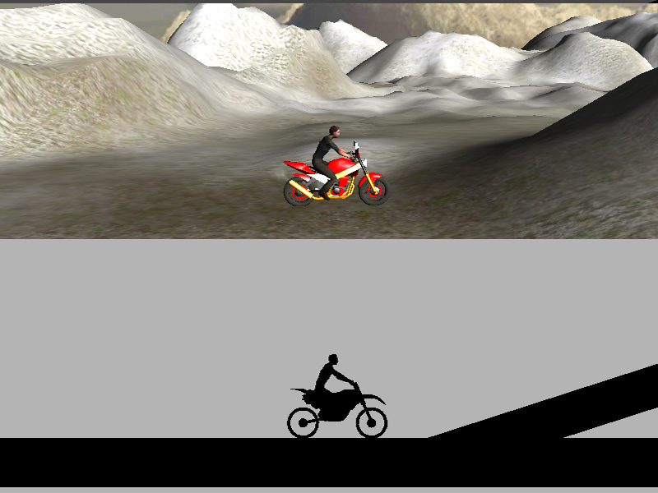

Package Description and contents
This game is about doing acrobatic tricks to get scores. Do as many tricks as you can to get more score. To win the level you must reach the finish.
There are used free things:
Motorcycle model is downloaded from: http://www.turbosquid.com/3d-models/3d-motorcycle-games/349482
Using male character pack from Mixamo: https://www.assetstore.unity3d.com/#/content/124
Skybox textures are downloaded from: http://www.redsorceress.com/skybox.html
Sound effects are downloaded from: http://www.sounddogs.com

A Description of the Game's Library Items
Open the game project to look at the library folders:

- MaleCharacterPack: Contains three 3D models from mixamo

- Materials: Contains the materials used within Unity.

- Motorcycle: Contains models (2D / 3D) of motorcycle.

- Prefabs: These are the objects you actually play with in-game, comprised from several elements put together in a single object (3d model, script, sound, etc). For example, motorcycle model, attached with script, audios, materials and such other components.

- Scenes: These scenes are complete levels which you play as usual.

- Scripts: Here are small pieces of code you add to your prefabs to make them interactive. You'll find a scripts (C# and JS versions) for motorcycle controlling, body collision detecting and react accordingly (detach ragdoll from motorcycle)

- Skybox: Contains textures and material for skybox.

- Sounds: Contains sound effects (engine loop, bones crack, hit, crowd)

- Standard Assets: Contains unity’s standard assets, physics materials, camera and utility scripts, terrain textures.

- Terrains: Contains 2 terrain created in unity.

- Textures: Contains textures for GUI textures, dirt particles and backflip/frontflip particles.

A description of Motorcycle_Controller and Bodytrigger scripts:

Motorcycle_controller
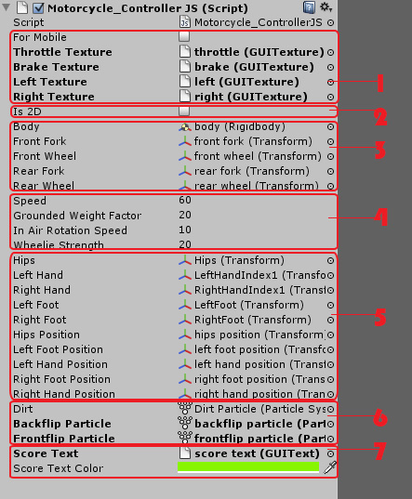
This script is used to controll and change motorcycle characteristics. Detects inputs from keyboard or touches, alligns ragdoll to motorcycle, plays corresponding particles and shows score.

Group 1
If “For Mobile” checkbox is checked, than you’ll need to enter GUI textures which will be used to controll motorcycle with touch inputs.

group 2
If “is 2D” checkbox is checked physics calculation will occur only in 2D space

group 3
Here must be put motorcycle’s body, front/rear forks and wheels transforms

group 4
These determains motorcycle’s characteristics

group 5
Here must be put biker’s bones and transforms used to position bones to correct place.

group 6
Here must be put particles which are shown when front flip or backflip is done. Dirt particle plays when motorcycle goes on object tagged as “Ground”.

group 7
This is GUI text and its color to show score.

bodytrigger
This script is used to detect collision, play sounds if crashed and show GUI texts when player wins or crashes.

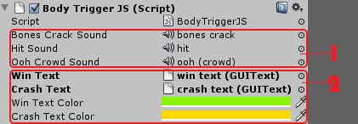

group 1
These are sounds which are played when the biker is crashed.

group 2
These are GUI texts and their colors which are shown when player wins or crashes.

A guide on how to add your biker
Firstly you’ll need to import your skinned mesh and make ragdoll from it. Enter in “Gameobject -> Create Other -> Ragdoll” and follow the instructions. After that when you already have a ragdoll, put it on scene and allign to motorcycle. Turn on “isKinematic” in inspector menu for
Hips, foots and hands and add them in “Motorcycle_Controller” script too. Put it on “Ragdoll” layer, add as a child in Motorcycle object and now you are ready to go.
P.S. To create layers, there is layers drop down list in inspector menu upper right corner and from there you can add new ones.

A guide on how to add your motorcycle
To create your own motorcycle the simplest solution is to import your 3D model splitted to body, front fork, front wheel, back fork, back wheel and change already assigned motorcycle’s meshes in inspector menu. In such way the configuration will be same, only meshes will be changed.
If you want to make motorcycle from zero, you’ll need good understanding to physics joints. Wheels are jointed to forks with “Configurable Joint”, locked all movement and rotation except “Z” axis. Front fork uses “Configurable Joint” too and rear fork uses “Hinge Joint”. The motorcycle and all its parts must be on “Motorcycle” layer.
This is a big topic and if you really want to dive in I suggest you to read about joints here:
http://docs.unity3d.com/Documentation/Components/class-ConfigurableJoint.html
http://docs.unity3d.com/Documentation/Components/class-HingeJoint.html

-------------------------------------------------------------------------------
I advise you to look further into the scripts and customize it to your pleasure. Don't hesitate to send me suggestions and feedback to temo_koki@yahoo.com
Good luck with your modifications!

